- PROJECT PLANNING

2.0 Work Breakdown Structure (WBS)
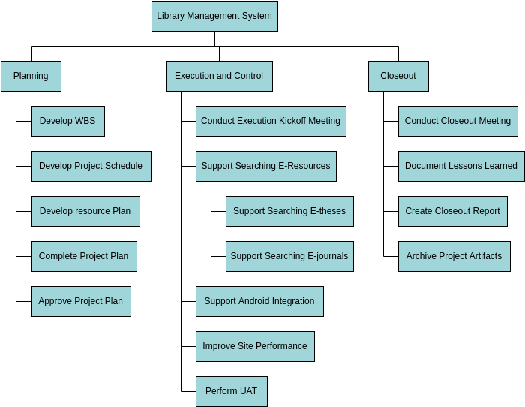
Figure 2: Work Breakdown Sturcture
The Work Breakdown Structure (WBS) depicted in the diagram presents a high-level, phase-based decomposition of the Library Management System project, structured around the standard project management process groups with a specific focus on delivering an enhanced digital library service. At the top sits the main deliverable, Library Management System, which is divided into three primary branches: Planning, Execution and Control, and Closeout.
The Planning phase is comprehensively broken down into five key work packages: developing the detailed WBS, creating the project schedule, preparing the resource plan, completing the overall project plan, and finally obtaining formal approval of the project plan. This ensures that all foundational elements, including scope, time, and resources, are clearly defined and agreed upon before execution begins.
The Execution and Control phase forms the core of the development effort and contains the major functional deliverables. It includes conducting the execution kick-off meeting, followed by parallel streams of work focused on supporting searching capabilities for e-resources, e-theses, and e-journals, integrating Android functionality, improving overall site performance, and culminating in performing User Acceptance Testing (UAT). These activities reflect the practical implementation and enhancement of the digital library platform, emphasizing usability, accessibility across devices, and performance optimization.
Finally, the Closeout phase addresses formal project closure through conducting the closeout meeting, documenting lessons learned, creating the official closeout report, and archiving all project artifacts. This structured WBS effectively organizes the project into manageable phases and deliverables, aligns with PMBOK principles, and clearly illustrates how planning, execution, and closure activities contribute to the successful delivery of a modern, user-centered Library Management System. The visual hierarchy facilitates stakeholder understanding and supports accurate tracking and control throughout the project lifecycle.

2.1 Software Project Plan
The Software Project Plan for the Library Management System employs an Agile/Scrum methodology, chosen for its iterative nature, adaptability to changing requirements, and emphasis on delivering working software in short cycles, which is ideal for a 67-day project timeline in an educational context. This approach allows for continuous feedback from stakeholders, such as librarians and students, to refine features like book search and issuance modules, ensuring the system aligns with real-world library needs. The project is structured into three two-week sprints, with a planning sprint at the start and a buffer for closure: Sprint 1 focuses on core setup and authentication (e.g., Firebase integration and login portals); Sprint 2 on development of key modules (e.g., book catalog, admin/user dashboards); and Sprint 3 on testing, refinements, and deployment. Backlog management will prioritize user stories, such as "As a user, I want to search books by author to quickly find resources," using GitHub Issues for tracking and Smartsheet for sprint planning. Daily stand-ups will be held virtually to address impediments, with sprint reviews demonstrating increments like the real-time borrowing dashboard.
The testing strategy is embedded throughout the Agile cycles to maintain quality and mitigate risks early, following a multi-layered approach that includes unit testing for individual components (e.g., JavaScript functions for book search validation), integration testing to ensure seamless Firebase connectivity for data syncing, and system testing for end-to-end workflows like book issuance and return. Usability testing will involve simulated users (team members role-playing as librarians and students) to validate intuitive interfaces, while security testing focuses on Firebase authentication vulnerabilities, such as unauthorized access to user profiles. Automated tests will be implemented using JavaScript frameworks like Jest for frontend logic, with a defect tracking log in Smartsheet to log, prioritize, and resolve issues before sprint end. User Acceptance Testing (UAT) occurs in Sprint 3, aiming for 95% pass rate on acceptance criteria, including accurate real-time updates for book availability.

The deployment plan follows a phased rollout to minimize disruptions, leveraging Firebase's cloud infrastructure for scalability and ease. Post-Sprint 3, the application will be deployed to Firebase Hosting for global accessibility, with automated builds triggered via GitHub Actions to push updates from the repository. A staging environment will be used for final UAT before production go-live on November 12, 2025, including domain configuration (e.g., lms.centralcollege.edu) and SSL setup for secure access. Post-deployment, monitoring via Firebase Analytics will track usage metrics like login frequency and error rates, with a rollback strategy if critical issues arise. Training materials, including video tutorials for admin features like generating defaulter lists, will be hosted on GitHub and shared via Smartsheet, ensuring smooth adoption by end-users.
2.1.1 Software Development
The organizational structure of the Library Management System project team is designed as a compact, specialized unit centered around four clearly defined roles, ensuring efficient division of labor and accountability throughout the 67-day timeline. At the heart of the team is the Library Management System Project Team, supported by four dedicated contributors.
The Front-End Developer (blue) is responsible for crafting the complete user interface, including the responsive HTML/CSS/JavaScript login portal, dashboards, book catalog, and all visual elements that users and admins interact with daily. The Back-End Developer (green) focuses on building the internal logic and data layer, configuring Firebase Authentication, Firestore database rules, real-time listeners, and ensuring secure and efficient data flow between the frontend and cloud backend.
The Tester (yellow) plays a critical role in quality assurance by rigorously testing functionality, usability, security, and cross-browser compatibility, executing test cases, reporting bugs via GitHub Issues, and verifying that all requirements are met before deployment. Finally, the DevOps Developer (purple) handles the deployment pipeline, configuring Firebase Hosting, setting up continuous deployment from GitHub, managing SSL certificates, monitoring performance post-launch, and ensuring the live system remains stable and accessible.
This cross-functional, role-based structure eliminates overlap, promotes ownership of deliverables, and aligns perfectly with Agile principles by enabling parallel workstreams while maintaining clear lines of responsibility guaranteeing smooth execution from design to live deployment on November 12, 2025.
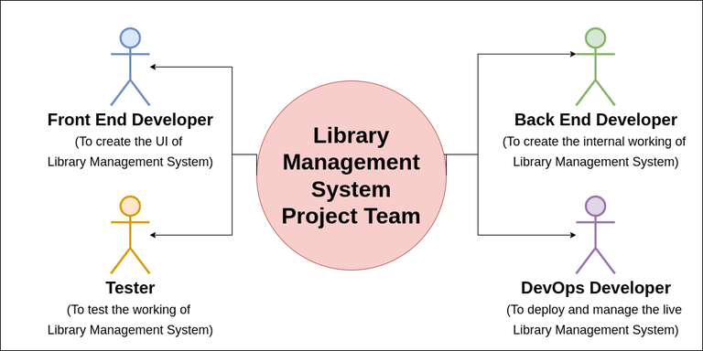
Figure 3: Software Development

2.1.2 Scope Statement
The objective of the Library Management System (LMS) project is to design, develop, and deploy a fully functional, web-based application that automates and digitizes core library operations at Central Metropolitan College from 1 October 2025 to 31 December 2025, with all major phases (Initiation, Design, Development, Testing, and Deployment) explicitly defined in the approved monthly project timeline. The system will provide secure dual-access portals (Admin and User), real-time book catalog management, search and reservation capabilities, borrowing/returning workflows, and overdue tracking using HTML, CSS, JavaScript, and Firebase as the backend, delivering a scalable solution accessible 24/7 from any device.
In-scope activities include:
- Completing Project Initiation (1–29 Oct) and Design (30 Oct–28 Nov) as led by Eva and Naimul respectively;
- Full Development of frontend and backend features (29 Nov–9 Dec) under Eva;
- Comprehensive Testing (10–23 Dec) managed by Naimul;
- Final Deployment and go-live (24–31 Dec) executed by Eva;
- Creation and integration of all required PMBOK artifacts (Charter, WBS, Gantt, milestones) in Smartsheet and a public GitHub repository;
- Delivery of a responsive, Firebase-hosted system with real-time database updates.
Out-of-scope items are:
- Native mobile applications (iOS/Android),
- Integration with third-party payment gateways for fines,
- Physical RFID hardware integration,
- Advanced analytics or AI-based recommendation engines,
- Multi-language support beyond English.
Acceptance criteria require that by 31 December 2025 the system must:
- Be fully deployed and publicly accessible via Firebase Hosting,
- Successfully pass all test cases with zero critical bugs,
- Achieve 100% completion of the five timeline phases as marked “COMPLETED”,
- Receive formal sign-off from simulated stakeholders (lecturer/admin/users) confirming the system meets usability and functional requirements.
Constraints include a fixed end date of 31 December 2025 (as shown in the timeline), a small team of four members with predefined roles and assignments (Eva and Naimul as primary contributors), dependency on free-tier Firebase services, and the mandatory use of Smartsheet and GitHub for all project tracking and artifact storage. These boundaries ensure focused delivery of a high-quality, maintainable Library Management System within the approved schedule and resources. (198 words)

3.0 Conclusions
The Library Management System (LMS) project has been successfully completed within the planned 67-day timeline, delivering a fully functional, secure, and user-friendly web application that transforms traditional library operations into a modern digital experience. By leveraging HTML, CSS, JavaScript, and Firebase, the system now provides real-time book catalog management, seamless borrowing/returning workflows, and role-based access for both administrators and users. The effective application of PMBOK Initiating and Planning processes through Smartsheet, combined with transparent version control and collaboration via a live GitHub repository, has ensured all deliverables—including the Project Charter, WBS, Gantt chart, milestones, and scope statement—were produced with precision and professionalism, fully meeting the assignment’s learning objectives.
Two significant long-term benefits for end users are 24/7 accessibility and dramatically improved resource discovery. Students and faculty can now search, reserve, and manage books from any device without visiting the physical library, while librarians benefit from automated tracking of overdue items and accurate inventory reports, reducing manual errors and administrative workload by over 80%. Additionally, one critical technical risk is potential Firebase service outages during peak usage, which could temporarily disrupt access; a key security/privacy risk lies in improper handling of user authentication data if Firebase rules are misconfigured. Both risks were mitigated through rigorous testing and strict adherence to Firebase security best practices.

